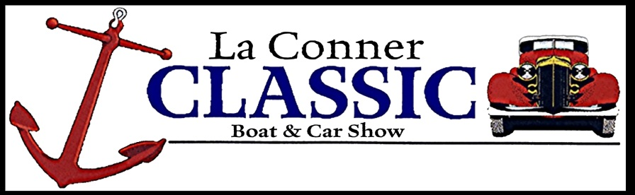

26th Annual La Conner Classic Boat & Car Show
August 1st 2026 / 1000 am – 3:00PM: Awards immediately following at the entertainment stage.

Boat Registration – Boats in the Water (Must Pre-Register by July 29th )

All makes and models of classic and vintage boats are invited to attend the La Conner Classic Boat & Car Show. Dock space is limited for boats in the water, so please register early to reserve moorage.
Registration fees for boats in the water will be $40.00 per entry. Entry fee includes 2 nights of moorage (Friday and Saturday nights) at the La Conner Marina.

Name(s)_____________________________________________________________________________ Address______________________________________________________________________________ City_________________________________________State_______________Zip___________________ Phone__________________________________E-mail_________________________________________
Boat Name______________________________________________Year__________________________ Builder/Manufacturer________________________________________ Overall Length_______________

EVENT FEE: $40.00
Credit Card Number: _____________________________________ Expiration Date: _________________

3 digit code on the back: __________
You can also mail a check to the address listed below

I have read and agree to all terms and conditions set forth in this application. Hold Harmless: Entrant agrees to hold the La Conner Chamber of Commerce, the Town of La Conner, Port of Skagit County/La Conner Marina and their agents harmless for any claim of loss or damage, of any nature, whatsoever, arising from participation in this event.

Signature________________________________________ Date___________________

Return application & checks to:
La Conner Chamber of Commerce
Classic Boat & Car Show
PO Box 1610
La Conner, WA. 98257-1610 / (360) 466-4778 / classic@laconnerchamber.com

